GIFT AID DECLARATION 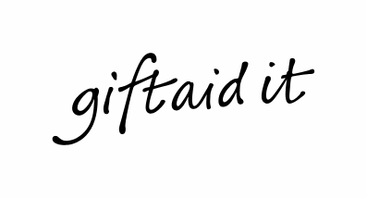
Through the Government’s Gift Aid Scheme, the Royal Archaeological Institute can claim an additional 25p for every £1 you donate. If you are a UK taxpayer, you can increase the value of your donations to us by 25%, at no extra cost to yourself.
Title........................... Forenames (in full)...........................................................................................

Surname.....................................................................................................................................................

Full home address......................................................................................................................................
......................................................................................................................................................
Postcode..................................................

Signature …………………………………………………………………………….
Date……………………..

I understand that if I pay less Income Tax and/or Capital Gains tax than the amount of Gift Aid claimed on all my donations in that tax year then it is my responsibility to pay any difference.
Please treat all qualifying gifts of money made today, in the past four years and for all future gifts of money as Gift Aid donations.
Please notify us if you:
- want to cancel this declaration
- change your name or home address
- no longer pay sufficient tax on your income and/or capital gains

If you pay Income Tax at the higher or additional rate and want to receive the additional tax relief due to you, you must include all your Gift Aid donations on your Self-Assessment tax return or ask HM Revenue and Customs to adjust your tax code.

